Experiment No.: 10

Title: Exploring DevOps Technology

Batch:B2 Roll No.: 1714086 Experiment No.:10

Aim: Exploring DevOps Technology ___________________________________________________________________________
Resources needed: ___________________________________________________________________________

Theory

Students are expected to write content on following topic w.r.t DevOps Technology
What is traditional SDLC
Why to use Devops
DevOps Tool chain

__________________________________________________________________________
Activities:
Students need to create their Account on GitHub, according their groups and show the activates like sharing doc, code, approving, changing committing within the groups w.r.t OOSE project topic
Attached the screenshot which (clearly) shows the activity
_______________________________________________________________________
Results:
Q1 ] What is traditional SDLC ?
The SDLC methodology is also referred to as "conventional systems analysis", "traditional systems analysis", "the systems development life-cycle" or the "waterfall model". Review and maintenance - this stage occurs once the system is operational and aims to ensure the continued efficient running of the system.

Q2 ] What to use DevOps ?
DevOps is a set of practices that combines software development and information-technology operations which aims to shorten the systems development life cycle and provide continuous delivery with high software quality.

Q3 ] DevOps Tool chain :
A DevOps toolchain is a set or combination of tools that aid in the delivery, development, and management of software applications throughout the systems development life cycle, as coordinated by an organisation that uses DevOps practices.
Screenshots of activities on gitHub :
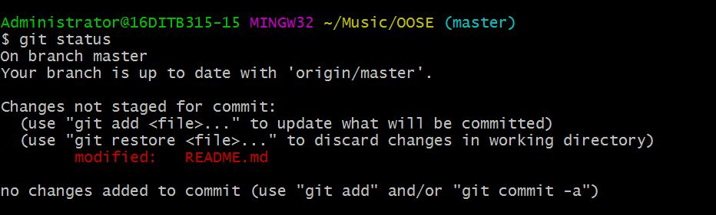

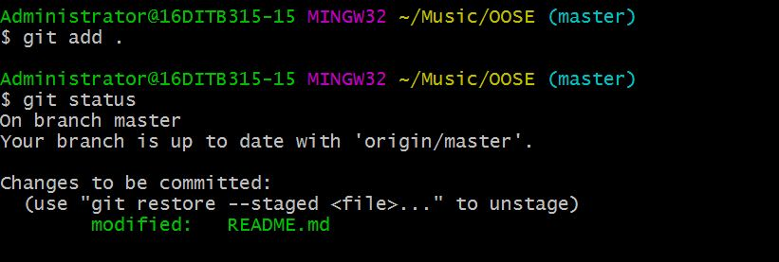

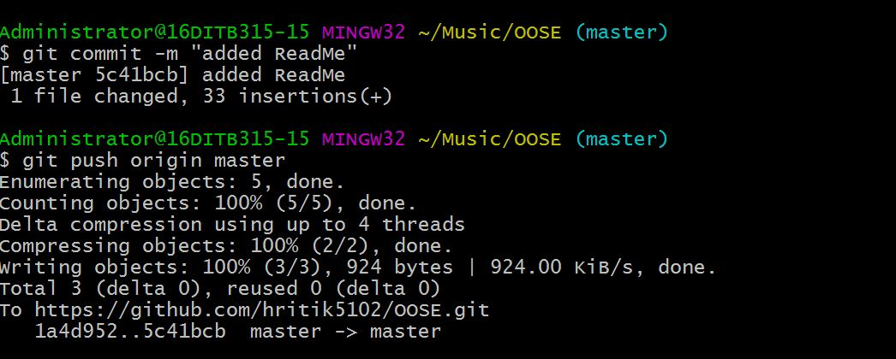

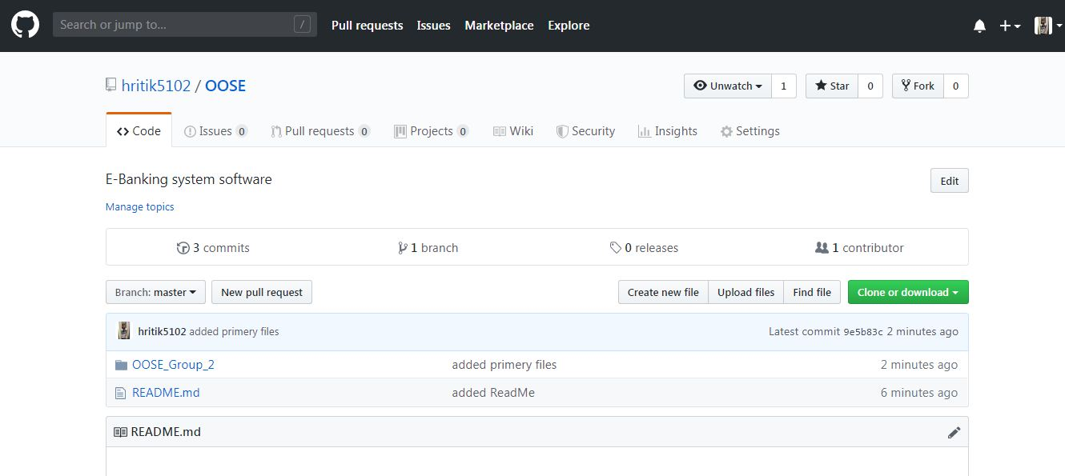

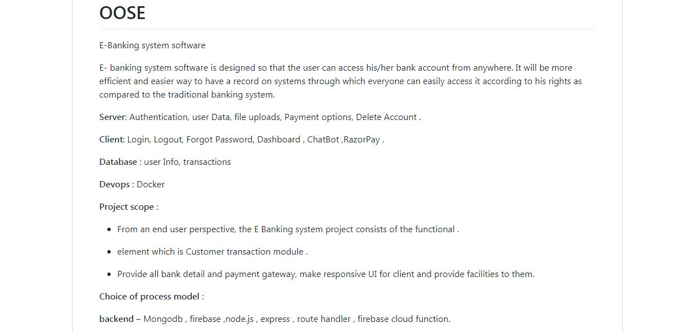

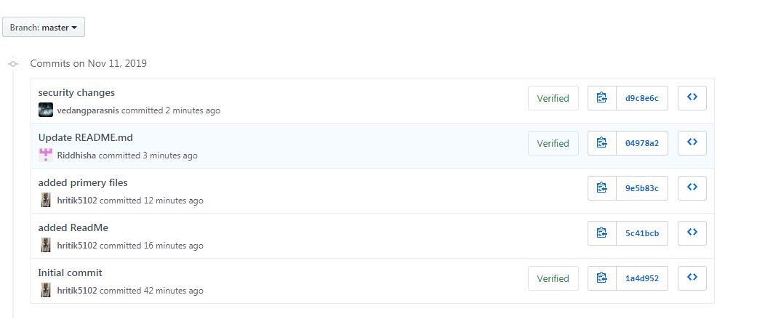

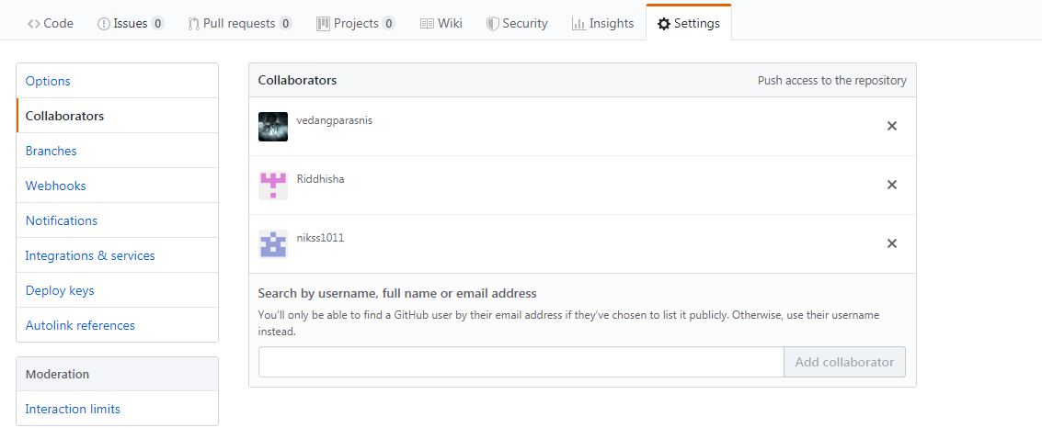

___________________________________________________________________________
Outcomes: Comprehend design pattern, architectural style usage and software planning paradigm.
___________________________________________________________________________
Conclusion:

Clearly explored the Devops technology and explored it thoroughly .

___________________________________________________________________________
Grade: AA / AB / BB / BC / CC / CD /DD

Signature of faculty in-charge with date

___________________________________________________________________________
References:

Books:
- Roger S. Pressman, Software Engineering: A practitioners Approach, 7th Edition, McGraw Hill, 2010.
- Technical report on Guidelines for Documents Produced by Student Projects In Software Engineering based on IEEE standards
3 https://git-scm.com/docs

